Stonewall and Beyond: The LGBT Movement and the Crusade for Equality
Submitted by: Justin Monaco, Social Studies Teacher; Marie Curie M.S. 158Q
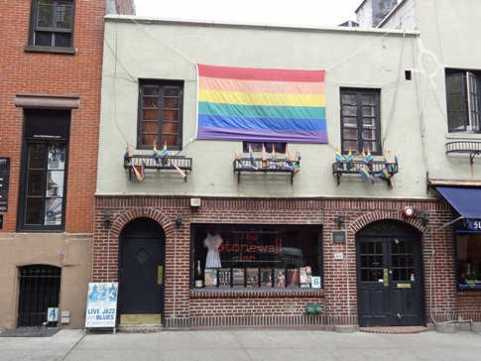
The Stonewall Riots and LGBT rights issues have recently been added to the New York State Social Studies framework in both eighth and eleventh grade United States History. This topic will be tested in future New York State Regents examinations. It could appear as a writing option on thematic essay topics such as civil rights and turning points or on document based questions as well as multiple choice questions.
The Stonewall Inn as it stands today.
This is a great time that the New York State Education Department officially recognizes the importance of LGBT rights and the impact the Stonewall Inn riots have had on United States history. This marks the moment of triumphant pride for all LGBT students and teachers that New York State has officially recognized a part of their history. The New York City Department of Education has recently issued a K-8 Social Studies Scope and Sequence which includes the study of LGBT rights. It is expected that they will do the same as they complete the Scope and Sequence for grades 9-12.
First, what does LGBT stand for? LGBT is an acronym that stands for lesbian, gay, bisexual, and transgendered. This acronym has recently been extended to emphasize a diversity of other sexual and gender identity-based cultures. The New York State K-12 Social Studies Framework mentions this as LGBT.
The Stonewall Riots were a series of spontaneous violent demonstrations by members of the gay community against a police raid that took place on June 28, 1969, at the Stonewall Inn in the Greenwich Village neighborhood of New York City. The Stonewall Inn Riots are widely considered to constitute the single most important event leading to the gay liberation movement and the modern fight for LGBT rights in the United States. It is frequently cited as the first instance in United States history when gays and lesbians fought back, marking the start of the gay rights movement in the United States and around the world.
Gay Americans in the 1950’s and 1960’s faced an anti-homosexual medical and legal system. In 1952, the American Psychiatric Association identified homosexuality as a mental disorder. Throughout the 1950’s and 1960’s the FBI and police departments kept lists of known homosexuals, their favored establishments and friends. The United States Post Office kept track of addresses where materials pertaining to homosexuality were mailed. Homosexuals (as was the term at the time) were persecuted. Being a homosexual was a risk that could cost someone their job and their reputation in their community. The Stonewall Riots was followed by several days of demonstrations in New York City and was the impetus for the formation of several gay, lesbian, and bisexual civil rights organizations. It is also regarded by many as history’s first major protest on behalf of equal rights for homosexuals.
On June 1, 2009, President Barack Obama declared June 2009 LGBT Pride Month, citing the Stonewall Riots as a reason to achieve equal justice under law for LGBT persons. Two years later, the Stonewall Inn served as a rallying point for celebrations after the New York State Senate voted to pas same-sex marriage. The act was signed into law by Governor Andrew Cuomo on June 24, 2011. President Obama also referenced the Stonewall Riots in a call for full equality during his second inaugural address on January 23, 2013. This was a historic moment being the first time a President mentioned gay rights or the word “gay” in an inaugural address.
“We the people, declare today that the most evident of truths-that all
of us are created equal is the star that guides us still; just as it guided our
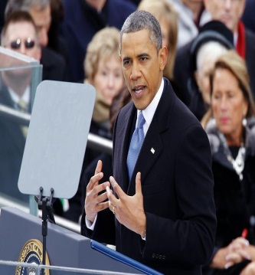
forbearers throughout Seneca Falls, and Selma, and Stonewall. Our
journey is not complete until our gay brothers and sisters are treated
like anyone else under the law. For if we are truly created equal, then
surely the love we commit to one another must be equal as well.”
President Obama at his second inaugural address.

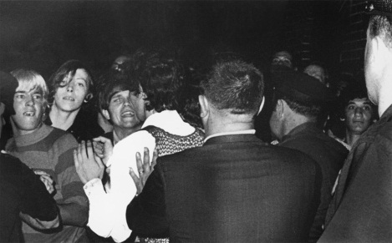
The date of June 28, 1969 is marked in American history as the day when the gay and lesbian community fought back against the constant government induced raids of gay and lesbian bars throughout the 1950’s and 1960’s. The summer of 1969 was a very violent period of riots and heated demonstrations as well as physical combat against police officers. Its importance today is the fact that gays and lesbians stood up for themselves. There were plenty of influential people among others who believed living a quiet subdued private existence suited them just fine. They were cowards! Others knew they were no different than there strait counterparts and demanded equality as an American citizen and as a human being. So many lives were destroyed in those few days of protesting for being involved in those riots exposed them to their bigoted families, friends, peers and their
Protestors demonstrating outside of the Stonewall Inn on June 28th 1969.
office of employment where those people disowned them or fired them for being gay.
The importance is that gays and lesbians wouldn’t be where they are today if the Stonewall Riots had not occurred. Legalizing marriage for the LGBT community, for example was barely a dream then, let alone a possibility; and that was decades ago. This is why the LGBT community had a GAY PRIDE celebration annually in New York City and major cities throughout the United States. The LGBT community is honoring those who took the risks and sacrificed their lives to have future generations of the LGBT community to live in equality.
For further research and information on the Stonewall Inn Riots and LGBT rights, I suggest the following websites:
www.glbtq.com www.glsen.org www.stonewall45.org
www.glbthistory.org www.lgbthistorymonth.com www.outhistory.org

