Association of Teachers of Social Studies/UFT
Winter – 2017
Volume 54 Issue 1 Winter 2017
In this issue:  - Teaching about the Presidential election  - Uncovering your past  - A Founding Father’s resurgence  - Free resources for your school  - Passages  - And more… |  | Alexander Hamilton’s grave at Trinity Church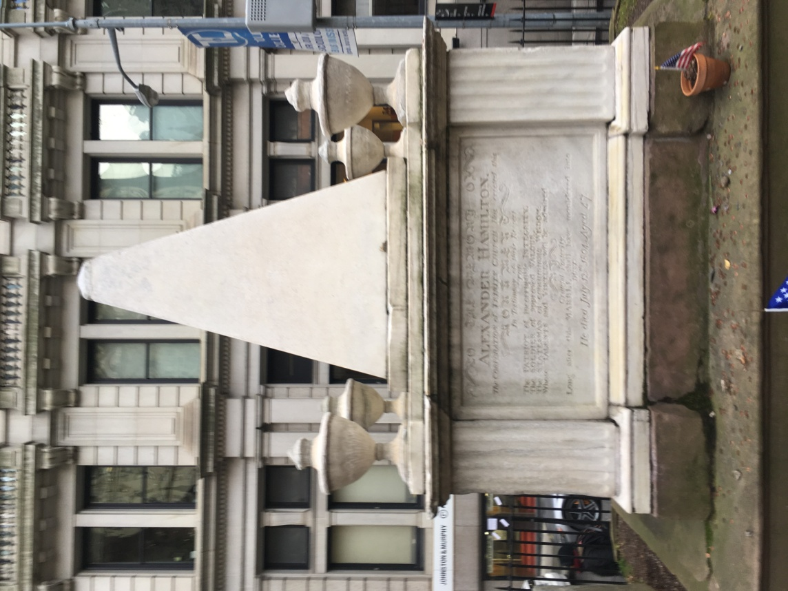
Patricia Urevith – Editor Mary Ann O’Grady Assistant Editor
UFT Professional committee Staff – George Altomare, UFT Liaison
Gary Mehra – Professional Committee Coordinator, Armando Mandes, Ronald Campana,
Winsome Johnson
Opieu:153
United Federation of Teachers
Michael Mulgrew
President
Emil Pietromonaco
Secretary
Melvyn Aaronson
Treasurer
Vice Presidents
Karen Alford
Richard Mantell
Janella Hinds
Sterling Roberson
Carmen Alvarez
Evelyn DeJesus
Anne Goldman
Association of Teachers of Social Studies/UFT
Joseph Zincone President Mathew Foglino Vice President
Pasquale D’Onofrio, Treasurer Eugene Resnick Secretary (*- past presidents)
Carolyn Herbst*, Executive Secretary, Nelson Acevedo, Ashley Acharya, John Agnello, Levi Anthony*, Angelita Antonio-Bartholomew, RoseMarie Armetta, Leigh Benin, Arthur Brown, Ron Campana*, Rozella Clyde*, Cynthia Copeland, Wanda Daniels, Robert Dytell*Matthew Foglino, Richard Forman, Michael Freydin, Dondre Jones, Stephen Lazar, Angela Magliano, Ledia Mara-Drita, Matteo Mannino, Justin Monaco, Deborah Straughn Moore*, Margaret Murphy, Mary Ann O’Grady, Taraneh Sabouri, Elliot Salow*, Alan Schulman, Harvey Seligman*, Helen Settles, Patricia Urevith*, Roni Wattman*, Alice Skinner Williams, Robert V. Williams, Mark Willner, Jeffrey Winograd*
Table of Contents

Letter from the editor page 3

Passages page 4

Teaching the Presidential Election page 6
By Professor Alan Singer

Hamilton by students from page 10
New Utrecht High School

Federal Reserve Lesson page 14

Emancipation of Sandy Wills page 19
By Patricia Urevith

Book Review by Alan Singer page 22

Letter from the editor  One of the reasons I like the location of the headquarters of the UFT is because it is in lower Manhattan. When I get off the R train at the Rector Street station, I can’t help but notice the gravesite of Alexander Hamilton that is located in the cemetery at Trinity Church. It remained largely unnoticed that is until the Broadway hit Hamilton opened. Now I notice more and more people visiting this historic site. Tour groups stop to allow visitors the opportunity to look at his grave.  When I was a teacher I took my students on walking tours of the area. One stop was always to create a scavenger hunt of all the interesting people who are buried at Trinity Church. The students were always amazed that a founding father is buried in New York City. But that is the beauty of lower Manhattan. Just to think that men like Washington, Jefferson, and Burr walked these streets. In this edition of the journal we have students’ responses to the hit play.  Another great place to visit is the Hamilton Grange where Hamilton lived. It is said that he found great peace at his home. This home which is operated by the National Parks Service is opened to the public and encourages school visits. When I went during December the tours were all booked. It is suggested that you arrive early for the tours. | This year’s recipient of the Rosa Parks award is Cheryl Wills author and news anchor from New York 1. She wrote an incredible book about her ancestor who served in Lincoln’s army. I truly think it is a book that should be in everyone’s school library.  What can we say about the presidential race? That is a topic that historian/educator Alan Singer addresses in his article republished with permission from the Huffington Post. He always gives great suggestions that can be duplicated in your classroom.  A book review by Alan Singer and much more.  I am always looking for work that can be used in this journal. Please, if you have a suggestion, or article please send it to me at:  ATSS/UFT  52 BROADWAY  NEW YORK CITY, NEW YORK  And remember, social studies is important. It teaches not only about our past, but presents issues that can be addressed in our future.  Be historians!  Patricia Urevith

PASSAGES
Congratulations to Mary Ann O’Grady who is not the Assistant Journal Editor. I am sure there will be less typographical mistakes thanks to her watchful eye!
CONGRATULATIONS!
Carolyn Herbst, Association of Teachers of Social Studies / United Federation of Teachers (ATSS/UFT) Executive Secretary, ATSS/UFT Sage Newsletter Editor and ATSS/UFT Past President /Chairperson was this year's recipient of the New York State Council for the Social Studies (NYSCSS) Continuing Service Award at the Awards Banquet Dinner on Friday, April 1, 2016 at the NYSCSS Annual Conference at the Albany Downtown Hilton Hotel, Albany, NY. She has served on the NYSCSS Board of Directors in many capacities over many years, and presented numerous workshops at NYSCSS Conferences since 1979. She was also recognized for her long service in ATSS/UFT and the National Council for the Social Studies. Several tables of reserved seating were provided for her family and colleagues, from ATSS/UFT, the New York City Department of Education, the Long Island Council for the Social Studies, and the UFT Capably Disabled Committee who were there to support her. Several other awards were presented for Teachers and Supervisor of the year at various levels. It was an elaborate event with a full printed program, a student string orchestra, flower centerpieces at each table, speeches about the awardees and lots of photographs. Congratulations to Carolyn.

ATSS EXECUTIVE BOARD MEMBER HONORED
Queens Borough President Melinda Katz and NYC Councilman and Education Chair Daniel Dromm honored Justin Monaco, a Social Studies teacher and an ATSS (Association of Teachers of Social Studies) Executive Board member at the 2016 LGBT Pride Celebration at the Queens Borough Hall
At the event, Borough President Katz and Council Member Dromm highlighted the many contributions that Justin Monaco has made to the LGBT rights movement in the Borough of Queens.
Justin began his career as a Social Studies teacher at MS 158 in Bayside and is currently teaching at MS 157 in Rego Park. He has devoted his time to bringing awareness to LGBT equality and inclusiveness, upon the recent changes to the New York State Framework and Regents examinations with the addition of the teaching of the Stonewall Inn Riots and LGBT rights. He has done workshops on incorporating LGBT history and issues into NYC classrooms. Justin has presented to the NYC Social Studies Supervisors Association, the ATSS /UFT GMNY Social Studies conference and the NYS Social Studies Teachers and Supervisors Education conference in Albany. His presentations dealt with the influence of gay life during the Harlem Renaissance, the impact of the Holocaust upon gay males, the Lavender Scare of the 1950s, the Stonewall Inn Riots, Former President Obama’s impact on the LGBT community and the teaching of court decisions both favorable and unfavorable to the LGBT community.
Justin has previously written two articles on the Stonewall Inn Riots and The Lavender Scare which have appeared in previous UFT Social Studies Quarterly Journals.

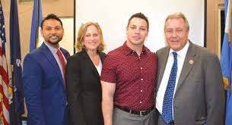
(Justin Monaco standing next to City Councilman Danny Dromm)

Former ATSS/UFT executive board president, Rozella Clyde is pursuing a political career in New Jersey. She already started her campaign!

Teaching Election 2016 the Morning After and for the Next Four Years.
By Alan Singer Social Studies educator, Hofstra University.
(This article is reprinted from the Huffington Post with permission from the author). (The views expressed in this article of those of Alan Singer)
Part I is Alan’s analysis of Election 2016. I open with my views as a historian, teacher, parent, grandparent, and citizen about what happened and my concerns about the future of the United States and the world. In Part 2 teachers partnered with the Hofstra University teacher education program discuss how they are addressing the election results in their classrooms.

PART 1 Alan’s Analysis of Election 2016

- I was surprised but not shocked by the Presidential election results. Donald Trump, the Republican Party candidate, was elected President of the United States with a majority of the electoral vote, although almost two million more people actually voted for Democrat Hillary Clinton. The “split” suggests that Trump’s election was a “correction” rather than a “mandate,” although Trump and his supporters may not see it that way. Trump presented himself as the candidate of change who would “Make America Great Again.” Clinton ran to continue a legacy that included economic stagnation for many Americans. More people voted for Clinton but Trump won anyway.

- The electoral vote is a vestige of slavery days. It was originally designed to separate the people from power and to “balance” the electoral power of Northern and Southern states in the new nation. According to the Constitution eligibility to vote was decided separately by each state. The electoral vote system, which assigned a set number of votes to each state based on population with a minimum of three, meant no state could “ stuff the ballot” by allowing a greater number of people including women, Blacks, the poor, or non citizens, to vote. The electoral vote system is an antiquated relic of an unjust past, but it is not going to change. That would require a Constitutional Amendment approved by three-fourths of the states, but the less populated states, and the Republican Party, that benefit from this system are not going to support a revision.

- The United States is sharply divided geographically, racially, ethnically, economically, and by education. The Red and Blue electoral maps show the Northeast and the west coast going heavily for Hillary and most of the rest of the country voting Republican. Most of the states with big cities went Democrat. States dominated by rural voters went Republican. White non Hispanic voters chose Trump over Clinton by 21%. Clinton held an 80% advantage among Black voters and took 65% of the Latino vote. Women supported Clinton by a significant but not overwhelming margin (54% to 42%. Two thirds (67%) of non-college educated Whites especially White men voted for Donald Trump. These divisions are not going to be easy bridge. It may never happen.

- The problems and divisions facing the United States and highlighted in the Trump campaign, the issues that got him elected President are genuine. But Donald Trump’s very sketchy solutions do not address the magnitude of these problems in any realistic way. Coal is never going to be a major source of fuel in the United States again, unless Americans somehow decide to give up breathing. Meanwhile, Trump’s proposal to ignore environmental concerns and expand coal production and use would undermine international efforts to slow climate change in dangerous ways. A national survey reported that over seventy percent of Trump supporters thought American culture and its way of life had changed for the worse since the 1950s. One reason for this longing for the past is that it was an era of dynamic economic growth in the United States which meant good, higher paying jobs, at least for White men. But the economic conditions at that time were historically unique and will never return. The industrial capacity of Europe and Asia were destroyed by World War II. Not only did the United States have no economic competitors but it had new markets for its goods as it rebuilt these regions of the world. Today the world suffers from a glut of manufactured goods, much of it produced cheaply in other parts of the world. A large number of new factories will not open in this country no matter what Donald Trump promises and in the factories that do open the assembly line will be “manned” robots and computers, not people. Longing for the 1950s also means longing for an era when women were subservient to men, Blacks were legally segregated from the rest of society, a new wave of post-1965 immigrants had not yet arrived in the country, and gays and lesbians were criminalized. Trump was able to mobilize his voters by raising legitimate economic hopes, but also by playing to bigotry.

- Donald Trump is impulsive and irresponsible, but not ideological on most issues. The goal of “opposition” should be to prevent permanent damage to the environment. Constitutional Rights especially for minorities and women, the economy and global alliances. This will not be an easy task, especially because many of Trump’s supporters are blind right-wing ideologues and they control Congress and will soon control the Supreme Court. While within the Republican Party there are irrational and dangerous groups like the “all-right” which embraces racist and anti-democratic ideas, they do not define the entire party or everyone who voted for Trump. Hopefully it will be possible to enlist Republicans willing to put country before party, people like the Bushes, Mitt Romney, John McCain, Colin Powell and Condoleeza Rice, to resist Trump’s more outrageous policy initiatives although I am not sure.

- The Democratic Party must either change or become irrelevant. Republicans now control the Presidency, the Congress, and a large majority of state governments. The underlying message of the Democratic Party for the past forty years fails to inspire many voters and they need to change it. Jimmy Carter, Walter Mondale, Michael Dukakis, Bill Clinton, Al Gore, John Kerry and Hillary Clinton each argued in some way that they were smarter, more experienced and better qualified to be President than their opponent and that if elected they would govern better. In general, this was a losing message. Barack Obama won the presidency because his message was hoe for the future. He was actually the less experienced of the candidates. The Democrats need to nominate candidates more like Barack than like Hillary. Part of the change is having a more left-progressive program a la Bernie Sanders and convincing people you will stand by it.

- I am a big supporter of protest marches. I went to the one in Manhattan. But protest marches are not a substitute for building a political movement. For the last fifty years, I have swung back and forth between believing that leadership for political and economic change would only come from a new Third Party and the hope that somehow the left could capture the Democratic Party and transform it into a force for social change in the United States. At this point the political right, the Tea Party, and their network of allies, has demonstrated that you can take over and reshape a major political party. It appears to be the best way to win from the grass roots up, by taking local, municipal, and state offices and building a political movement within the existing electoral structure. I have decided to shift my party affiliation back from the Green Party to the Democratic Party. If no one else steps forward, I will consider running in the 2022 Democratic Party primary as a left-progressive against Chuck “Senator Wall Street” Schumer.

Part 2 Teachers Discuss How they Address the 2016 Election Results
Teachers need to be clear about what they think and their goals for a lesson as they begin to plan. What you teach, and how you teach is going to be different depending on the age of your students. It also needs to reflect your understanding of who your students are. For younger children, discussions should center on fairness, how we treat each other, and that our classrooms and our country are governed by rules and laws, that leaders must also follow. I want older students to examine the American political and economic system more critically, to define the kind of country they want to live in, to think of themselves as active participants in a diverse and democratic community, and also to experience possible and definitely legitimate decision by students would be to become political activists.

Mike from Queens NY wants teachers to help students “learn to deal with increasing intolerance and to resist.” He expects “The Democrats will now move to the right and accommodate Trump and Republican rule” To help his students understand what is happening in the United States, Mike developed a series of research assignments for before and after the election for his high school students.
- Students created informational pamphlets about the history of voting rights in the U.S. and current efforts to restrict voting rights and reported suppression of voting in some districts on Election Day.
- Students examined the duties and responsibilities of the president and the role of money in elections.
- Students learned about the Electoral College, including examination of past electoral results. Students took part in the Great Electoral Vote Extra Credit Contest to pick winner and closest to the number of electoral votes.
- Students undertook a presidential debate project during which they wrote and presented candidate statements on a variety of topics.
- Students were given the opportunity to write and discuss their personal reactions to the election results.
- Students conducted a demographic analysis of the results

Rich, a Long Island, NY middle school teacher created this activity for his students who are almost all Black and Latino.

- Donald Trump was elected President of the United States of America. Today we will examine (1) How Trump won; (2) discuss your feelings, concerns and reactions and (3) examine what role we must play in our democracy.
For our first activity examine the election map
Questions:
- List five states where Donald Trump was the winning candidate?
- In your opinion, what are some reasons people may have voted for him?
- Donald Trump’s speech he congratulated Hillary Clinton and said he would be the president to all people. He said, “Now it’s time for America to bind the wounds of division – have to get together.” He said. “To all Republicans and Democrats and independents across this nation, I say it is time for us to come together as one united people.”
Questions:
- What is your response? Do you think he can do this?
- What power or responsibility do you have in a democracy if you have different beliefs or values than your President or Government?

…Part of growing as a social studies educator is realizing that adaptability and a means of gauging the mood of your classes is just as critical as lesson preparation. It became clear that what my students required was a “safe-space” to discuss their post-election thoughts and feelings.

Hamilton
By students from New Utrecht
Editor’s note: Founding father Alexander Hamilton is enjoying resurgence in popularity thanks to the Broadway hit Hamilton. The play offers high school students a chance to see the hit. These are their responses to the play. (Special thanks to Ms. Golofayeva and Mr. Chan)
On Wednesday, November 2nd 2016 some of the New Utrecht High School classes were given the opportunity to go see Hamilton on Broadway. This was a day that I will never forget. History class was held at the Richard Rodgers Theatre with the cast of Broadway's "Hamilton." Students from public schools were able to create their own performances based on historical sources and perform their pieces on the "Hamilton" stage. The best moment was when I found out that my group was going to be representing New Utrecht High School. I was very excited and satisfied. Stephanie, Roman, and I were the group that was chosen from New Utrecht High School to perform on the Richard Rodgers Theatre stage. We wrote a rap on "Patrick’s’ Henry Give me Liberty or Give me Death speech." The experience of performing on a Broadway stage was phenomenal and a dream comes true. I would have never had the chance to perform if it wasn't for Ms. Golofayeva, Mr.Como, Mr.Chan, and Ms. Martinale, who supported me tremendously throughout this entire experience. It was the experience of a lifetime. We met the cast of Hamilton and watched the wonderful performance. We were learning about Alexander Hamilton when we went to see the show, which fit the curriculum really well. This was an experience that will always live with me. I would never have had this experience without the support from my teachers. November 2nd is a day that I will always remember.
~ Aziza Abedrouf Period 5 A.P.U.S History.

This whole project has honestly been one of the most fun and entertaining ways that has gotten me to learn about a specific topic in all of my life. Firstly, the project allowed not just me, but all of my peers and all of the students who participated in this project to voice their creativity in a way that they maybe not have been able to do before. Secondly, I had amazing people in my group, Roman and Aziza, and together, we were able to come up with an original and catchy piece of art that informed people of a historical event and person (which for us was Patrick Henry's Give Me Liberty or Give Me Death speech to the Second Virginia Convention in 1775). This also gave me and everyone else who performed their piece on stage a once in a lifetime opportunity to see the most popular Broadway play of all time as close as the first row to the stage. Also, I know that I would have never been able to afford the tickets to see this show, which I have been wanting to see for a while now because of the interesting and peculiar way it presents history. The show was absolutely amazing, just for the record. This project also correlated with our curriculum, since we actually were focused on events that Hamilton brought up in the show, such as the Revolutionary War, our Founding Fathers, precedents that George Washington set for the country (the Presidential Cabinet), presidential elections during this period, and so much more. Because of this, the show helped me memorize some information and receive one of the highest quiz grades I have gotten this year so far due to the quiz being on the time period that most of the show focused on. This project had also helped me get over my fear of public speaking a bit, I get nervous about presenting in front of groups of people, now I just think to myself "Stephanie, you have performed on a Broadway stage you can do this." This project has gave me a newfound passion for Broadway, and although I have loved singing and performing my entire life, it has made me think that although it's tricky, following a career in performing arts is not impossible or delusional in any way. There are so many people to give credit to; my amazing history teacher, Ms. Golofayeva, for making me believe that I could accomplish something like this, the assistant principals and administrators in my school that made this trip possible (such as Mr. Chan, Mr. Cuomo, and Ms. Martinelli), the DOE for giving every student involved an opportunity to do something so amazing, and the Gilder Lehrman Institute of American History and the Rockefeller Foundation for their generosity in making this project and experience possible. All in all, this project has changed not just my views on many things, such as how fun an AP United States History class can be, but also changed some of my views on ways of life, as crazy as that may sound. And hey, if you ask me a question pertaining to Alexander Hamilton, I may be able to answer it since I've memorized a lot of lyrics to a lot of songs from the show!
~ Stephanie Garcia, Junior at New Utrecht High School.

Dear Editors,
My name is Roman Sushevskyy, and I had the opportunity to perform on the stage of Hamilton. It was an amazing experience to not only sees a Broadway show, but to incorporate the topics and ideas from the show to what we were learning about in our current history class. Many young individuals do not get the opportunity or have to money to go out and see a show, and many do not get the opportunity to actually go backstage and perform an original piece of their very own on stage. I remember the time that my AP US History teacher told the group that I am part of, that they enjoyed our own original piece. I felt astonished, we did not have a long time to complete the song, but through the project we were able to cooperate and support each other to create the lyrics that will probably never leave my head, and a beat to go with it. I definitely could not have done this project without the amazing classmates that I worked with, Stephanie Garcia and Aziza Abedrouf who demonstrated an enormous amount of support throughout the process and gave their undivided dedication for the project. When it was show day, I had a slight worry but I did not want to stress myself out, so I stayed optimistic and the friends in the group definitely helped keep each other motivated and excited. We even had a little jam out session to Hamilton on the ride there. Once we arrived at the theatre, Stephanie, Aziza, and I were taken backstage and we were in awe. To actually see the backstage of the performers was an unforgettable moment and something I never thought I would experience in my life. Even minutes before we were about to go on stage to perform, Stephanie and Aziza kept us optimistic and we were ready for our time to shine. The moment when we were on stage and began to perform, a feeling of freedom and confidence and just pure joy to share something that we created was an experience I am forever grateful for. I left the stage with those two friends more confident and wanting to perform more than ever. I am definitely shy and was nowhere near confident as before this whole experience, and I still am however, but I remind myself of that wonderful feeling I got from performing and strive to feel that again. I believe opportunities like this are important, not only because they pertain to the lesson(s) and teaches us the history of our country, but it is also important for those who enjoy music because it helps showcase their talent. Opportunities to learn from different perspectives and styles such as learning history from music and performing are essential to our academic development!

~ New Utrecht High School Roman Sushevskyy AP US History and Government.

On Wednesday, November 2nd 2016 some of the New Utrecht High School classes were given the opportunity to go see Hamilton on Broadway. This was a day that I will never forget. History class was held at the Richard Rodgers Theatre with the cast of Broadway's "Hamilton." Students from public schools were able to create their own performances based on historical sources and perform their pieces on the "Hamilton" stage. The best moment was when I found out that my group was going to be representing New Utrecht High School. I was very excited and satisfied. Stephanie, Roman, and I were the group that was chosen from New Utrecht High School to perform on the Richard Rodgers Theatre stage. We wrote a rap on "Patricks’ Henry Give me Liberty or Give me Death speech." The experience of performing on a Broadway stage was phenomenal and a dream come true. I would have never had the chance to perform if it wasn't for Ms. Golofayeva, Mr.Como, Mr.Chan, and Ms. Martinale, who supported me tremendously throughout this entire experience of a lifetime. We met the cast of Hamilton and watched the wonderful performance. We were learning about Alexander Hamilton when we went to see the show, which fit the curriculum really well. This was an experience that will always live with me. I would never have had this experience without the support from my teachers. November 2nd is a day that I will always remember.
~ Aziza Abedrouf Period 5 A.P.U.S History

Life of a Dollar Bill (reprinted with permission from Federal Reserve Bank_ (Thank you Ashley Acharya)
Federal Reserve Bank of New York
Introduces the basic need for money, and the circular flow of resources between households,
businesses, government, and financial institutions as told by Mr. Dollar Bill. Teacher's guide outlines
goals, vocabulary, and discussion questions.
Description:
Grade Levels: 4,5,6,7,8
Document Type: Instructional Unit
This document may be printed.
FEDERAL RESERVE BANK OF NEW YORK
Teacher's Curriculum Guide
To
LIFE OF A DOLLAR BILL
Introduction:
This teaching packet has been designed to stimulate student interest and
enhance classroom instruction in economics. The packet can best be used as a
teacher introduces a unit of study on money. The packet consists of a poster
and fifty copies of a four-page illustrated booklet. It is essential you read the
four-page illustrated booklet prior to teaching your students the concepts
presented in the poster.
Goals:
The general goals of the packet are to develop in students an economic
understanding of how the currency component of the money supply gets into
circulation and how money flows facilitate in the production of goods and
services—our Gross National Product. More specific goals are to familiarize
students with the following economic concepts: the three kinds of money, the
purposes money serves, and how money, resources, and goods and services
flow between households, businesses, governments, and banks.
Vocabulary:
Bank Currency Gross National Product
Barter Economic Resources Households
Business Federal Reserve Bank Income
Checking Account Goods Services
Coin Government
Introducing the Lesson:
Teacher (holding a dollar bill in front of the class): "What is this in my hand?
What will it do for you? Where was it before I got it? Where did it originally come
from?" After discussion the teacher tells the students that they are going to learn
more about the life of a dollar bill.
Discussion and Reading Booklet:
Teacher (while distributing booklets to students): "This is a special booklet
about money that we will read and share together." The teacher should begin
reading the booklet to the students as they follow along in their own booklets.
The booklet should be used as a discussion tool and should not be read
straight through without stopping. For example, when the booklet states,
"Throughout history money has taken many forms," the teacher should use this
as an opportunity to discuss other items (animal skins, grain, shells, pots, rings)
which historically have been used as money.
In the course of the reading activity, delay putting up the poster until the booklet
states, “Dollar like me are printed by the treasury’s Bureau of Engraving and
Printing in Washington, D.C.” At this time put up the poster and point to the top.
showing the beginning of the life of a dollar bill. The teacher should relate to the
reading activity to the poster, pointing to various concepts, term, etc. After the
discussion activity the booklets should be replaced in the classroom where they
are readily available for students to reread and review.
Activities:
1. Set up a barter game and allow students to trade objects. Afterwards, discuss
complications that were encountered in trading, such as the fact that many
trades were required before getting what you want or that values were hard
to compare. Discuss how money makes trading easier.
2. Take a field trip to a bank to find out how cash and checking accounts are
handled. Back in the classroom display a large copy of a check on a chart
and have students practice writing checks on blank forms. Discuss why most
money used is in the form of checks.
3. Have students research information on Federal Reserve Banks. For example,
find the location of the Federal Reserve Bank nearest you. Find out if it burns
or shreds worn-out bills? If shredded, is it recycled?
4. As art activities, students could design their own dollar bills using appropriate
symbols or draw sequential cartoon illustrations tracing the paths in the life of
a dollar bill.
5. A creative writing experience could involve students personifying “Bill . . .
Dollar Bill." Their stories of Bill could describe his lifespan of approximately
18 months, being refolded at least 4000 times, and living in dirty, cramped
pockets or clean metal vaults.
Polly Gray
School Services Consultant
Arkansas State Council on Economic
Education

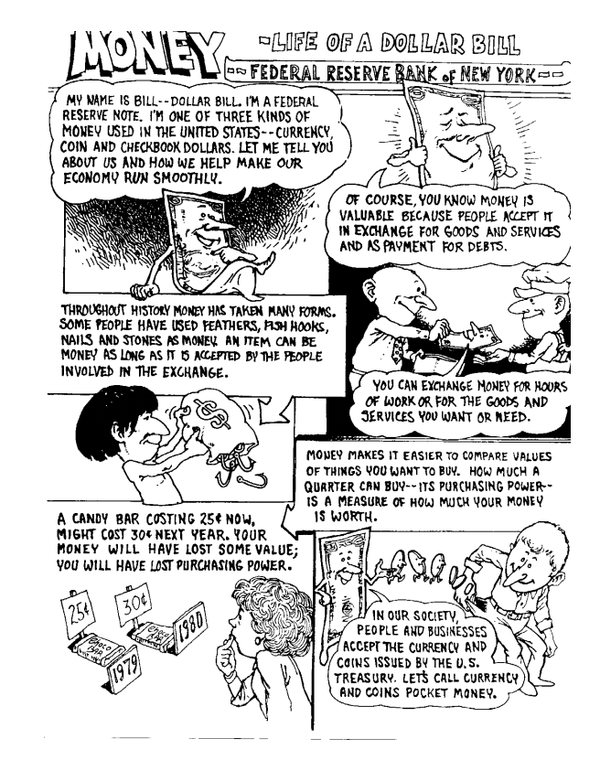

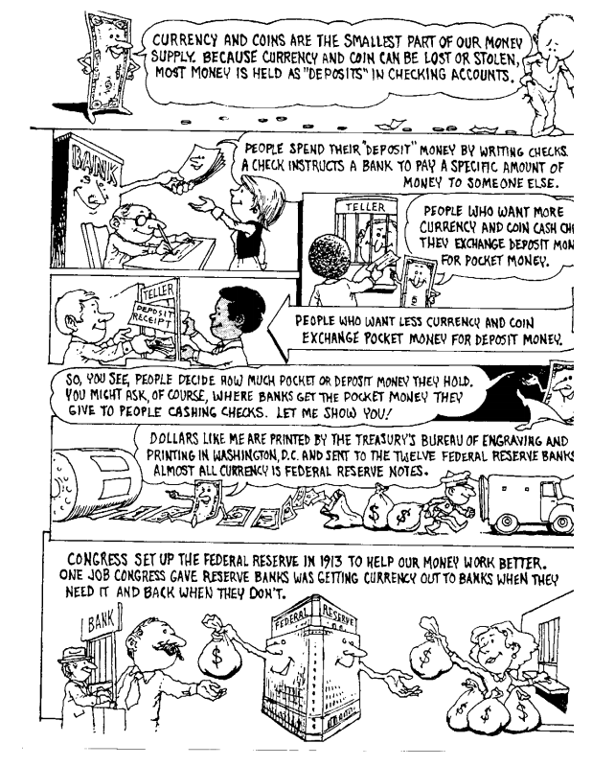

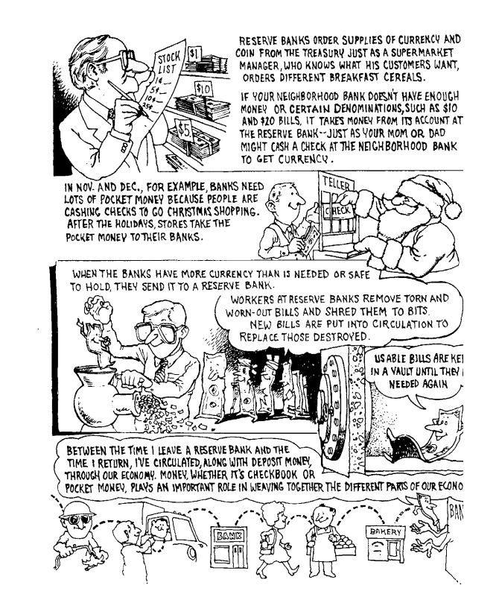

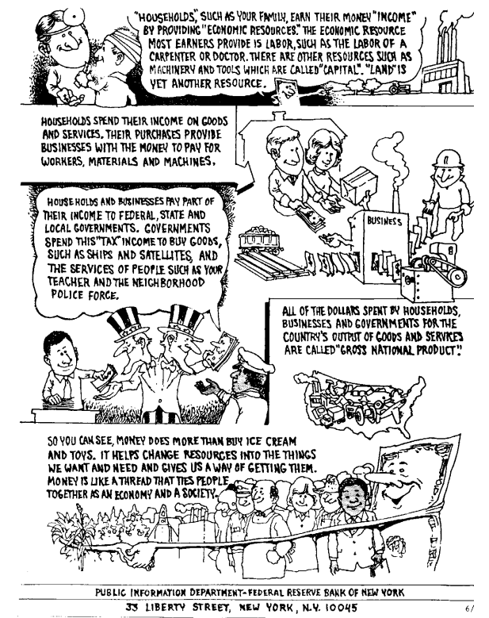

The Emancipation of Grandpa Sandy Wills written by Cheryl Wills by Patricia Urevith, Journal editor ATSS/UFT
One of the best books I read this year happens to have been a picture book written by Cheryl Wills entitled The Emancipation of Grandpa Sandy Wills illustrated byRandell Pearson and published by Light Switch Learning. It is the story of Wills quest to uncover her past by researching her genealogy.
And what a past her search revealed. It turns out that her great-great-great grandfather was Sandy Wills a runaway slave from Tennessee who joined Lincoln’s army. But her search did not stop there. Her writing based upon her research depicts life on a plantation. She writes how her ancestor was sold to the Wills family while his mother was sold to another family. It was heart wrenching to read how he was treated but inspiring how he never gave up hope. Sandy Wills became a freedom fighter and when the war was over he continued to fight for what was right. He found his mother and married a woman named Emma West Moore. When Sandy died at the age of 50, Emma became a fighter. She was denied Sandy’s pension from the army because she could not prove his date of birth. Cheryl explains how the enslaved were not taught to read or write making proof of birth almost impossible. However, Emma did not give up. She had the ingenuity that when given a Bible she wanted the names and births of her children written in the Book. She had her former owner write the names and dates of all her children which proved invaluable to receiving the pension. But I do not want to give away too much of this engaging story.

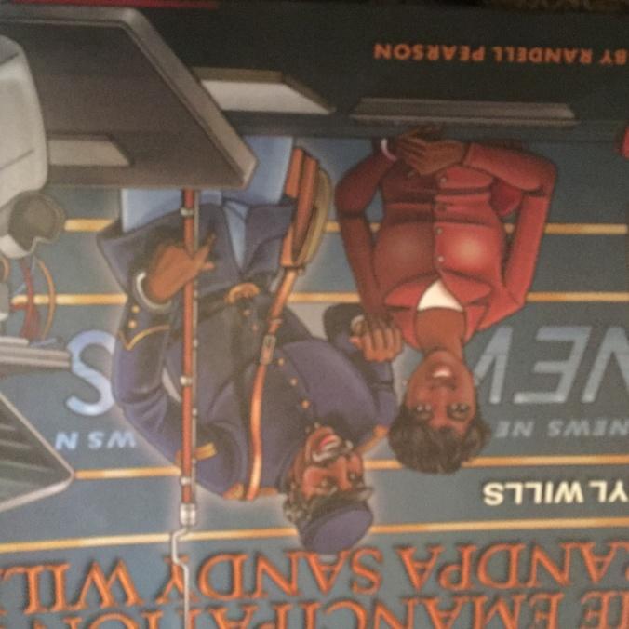
Cheryl Wills is an anchor and senior reporter with NY1 who has interviewed everyone from Maya Angelou to Secretary General Ban Ki-Moon. However, it is her passion for her history that makes reading these books so intriguing. Wills currently wrote a play about her ancestor’s life and has it performed at schools and other venues. She visits schools and discusses with them the importance of knowing their family tree. In the end she says, “Everyone makes a difference.”
The story is inspirational in so many ways. First, it depicts the true life experiences of one of Lincoln’s fighters for freedom. As I read it I wanted to learn more and more about the soldiers and the lives they led. And the story of Emma, Grandpa Wills wife is a lesson in will and determination. On another level, it is also the story of the importance of researching and learning about one’s story. Who knows what you can discover.
The book which I suggest for both elementary and middle schools can be utilized in the classroom in numerous ways. The first way is a read a loud. You might want to read the whole book or portions to your class. Afterwards, you can create discussion questions that you might want to use. There are examples of questions in the back of the book. I also suggest have the students write their responses to the story. Ask the children to write a review of the book.
As a project, I think creating a family tree would prove beneficial to the students. I once did this in the class room and the student brought to class a picture of her Cherokee ancestor. The girl became so proud of the fact that her ancestor was a Native American. Another aspect is to have your students interview their grandparents or another elder. They just might be surprised to find out about them!

Colson Whitehead’s the Underground Railroad a book review by Alan Singer (This article is reprinted from the Huffington Post with permission from Alan Singer)

I begin this review with two very important points. First, Colson Whitehead is an excellent writer. His novel, The Underground Railroad (New York: Doubleday, 2016) is always engaging and moves at a rapid pace. It won the 2016 National Book Award for fiction and was an Oprah Winfrey book club selection.

Second, despite its title, the novel is not about the Underground Railroad. At first I was reading the book as an historian. I found myself constantly correcting Whitehead in my head until I accepted that he was not really concerned with how historians understand and explain the past. The Underground Railroad, in the novel an actual railroad runs under ground, even slavery, were metaphors used to explore racism in the United States, the condition of Black life, people’s hopes, and people’s struggles, in the past and present. At a time when police violence against Black men seems to be almost a daily occurrence, this book is a statement that Black lives Matter.

On the Randall plantation in Georgia enslaved Caesar has an illicit copy of Gulliver’s Travels that he reads a few pages at a time to keep his mind free. He imagines his effort to escape enslavement, all life is like Gulliver’s effort to survive and return home. It is Caesar who convinces Cora to join him in a mad dash threw the swamps to a stationhouse where they can find a railroad station.

Gradually I started to view the book as a sort of contemporary Wizard of Oz story, to see Cora as a self-emancipated Black Dorothy on an impossible trip taken in horrendous times, and then I could join Whitehead and Cora on the fictional Underground Railroad in her search for freedom. Ridgeway, the slave catcher, is Cora and Whitehead’s Wicked Witch of the West. The friends and helpers she meets along the way, Black and White, have some parallels with characters from the Oz tale, although in the Whitehead’s imagined slave South, in a book written for a contemporary audience, most end up suffering horrible deaths.

Frederick Douglass makes an appearance in the novel as Elijah Lander, the son of a White father and Black mother from Boston, who travels the nation risking his life to speak out against slavery. Eugene Wheeler is a William Lloyd Garrison like character, although this time he is an abolitionist lawyer in New York City. Mingo is the accommodationist Booker T. Washington and also the Cowardly Lion, John Valentine is the flawed Wizard of Oz. Valentine Farm is a failed Emerald City that could not survive the power of White racism.

During the escape from slavery Cora meets Royal, a combination Straw Man/Tin Man and male Harriet Tubman who becomes her rescuer and lover. It is Royal who explains how “the Underground Railroad is bigger than its operators – it’s all of you, too. The small spurs the big trunk lines. We have the newest locomotives and the obsolete engines, and we have handcars like that one. It goes everywhere, to places we know and those we don’t (267)

Whitehead’s Underground Railroad is the struggle for human dignity, the struggle for social justice; we are all part of that struggle on the Underground Railroad. I strongly recommend the book.

Alan Singer is a professor of social studies education at Hofstra University. He is also a frequent participant at the annual Greater Metropolitan Social Studies Conference.

The DOE/SOCIAL STUDIES DEPARTMENT holds books talks at the National Archives. Subjects have included polio as well as Native Americans. These talks are an excellent way to not only hear authors discuss their books, but the National Archives presents primary sources that correspond to the discussions.

It is a great way to learn more about different subjects as well as meet colleagues. For more information contact the DOE/ SOCIAL STUDIES DEPARTMENT.

NOMINATE AN OUTSTANDING SOCIAL STUDIES EDUCATOR

Every year at the Greater Metropolitan Social Studies Conference awards are distributed for the Cohen Award. These awards are named for the outstanding educator and GMNY conference chair Bernard Cohen. An award is given to an elementary, middle and high school teacher. If you would like to nominate an educator, contact the professional committees’ office of the United Federation of Teachers.

